**Project: Woodson Park Academy & YMCA-ELC**

**Week Ending: June 21, 2019**

**THIS WEEK:**

* Demo Continues on existing school building.
* LDP approved 6/20/19
* CDCC has called in for pre-install meeting with COA

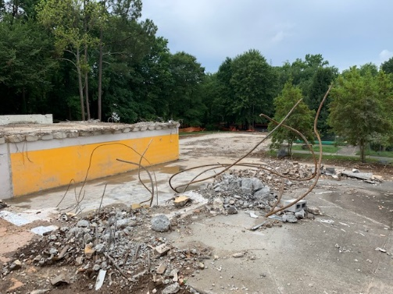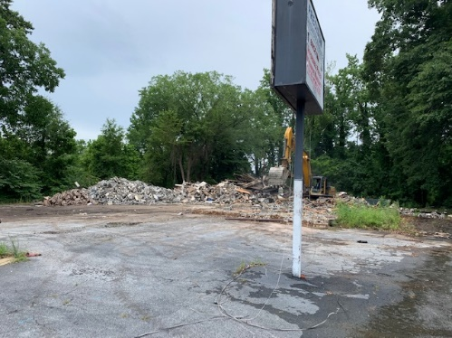

Transmission shop demo completed Demo of the vertical portion of the old school building complete

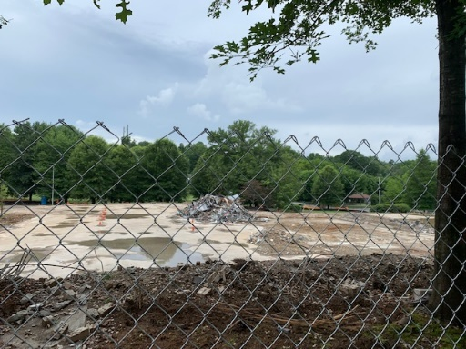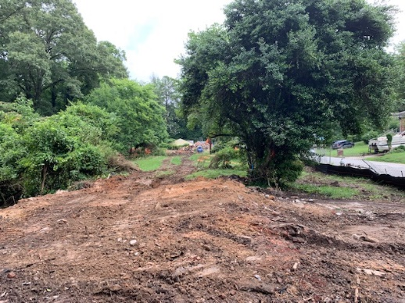

Demo continues on the existing All houses on Francis demoed

School building

**NEXT WEEK – June 17 thru May 21:**

* Erosion control per LDP plans
* Pre-install meeting with COA
* Jobsite trailer utility hook up on going
* Install web cam

**PAYMENT STATUS:**

* Gmp#1 $3,703,488.00
  + Paid to date amount $0.00
* GMP#2 $28,686,295.00
  + Paid to date amount $0.00

**SCHEDULED DATE OF SUBSTANTIAL COMPLETION**

* WPA – September 17, 2020
* YMCA-ELC - September 14, 2020

**PREPARED BY:**

* **Matt Dauber, Carroll Daniel Construction Co.**